Un hipotético nuevo tratamiento para una enfermedad neurológica que bloquea un determinado receptor celular disminuye la mortalidad asociada a la enfermedad de 50/1000 a 15/1000. En otras palabras, los individuos que deben esperar para recibir el tratamiento, incurren en esta mortalidad. Sin embargo, si la persona finalmente resulta no tener ese tipo de receptor celular, el tratamiento tiene un riesgo de mortalidad del 1%. Existe una biopsia cerebral profunda perfectamente precisa que permite recoger el tipo de tejido necesario para determinar si el receptor está presente, pero conlleva un riesgo de mortalidad del 0,5%.

A hypothetical new treatment for a neurologic disease that blocks a certain cell receptor decreases the mortality associated with the disease from 50/1000 to 15/1000. In other words, individuals who must wait to get the treatment, incur this mortality. However, if the person ultimately turns out not to have that cell receptor type, the treatment has a mortality risk of 1%. There is a perfectly accurate deep brain biopsy that allows the collection of the type of tissue required to determine if the receptor is present, but it carries a mortality risk of 0.5%.

1. Construct a decision tree to model the trade-offs of options for patients, using mortality as the outcome

Refer to the Amua file for the full model.

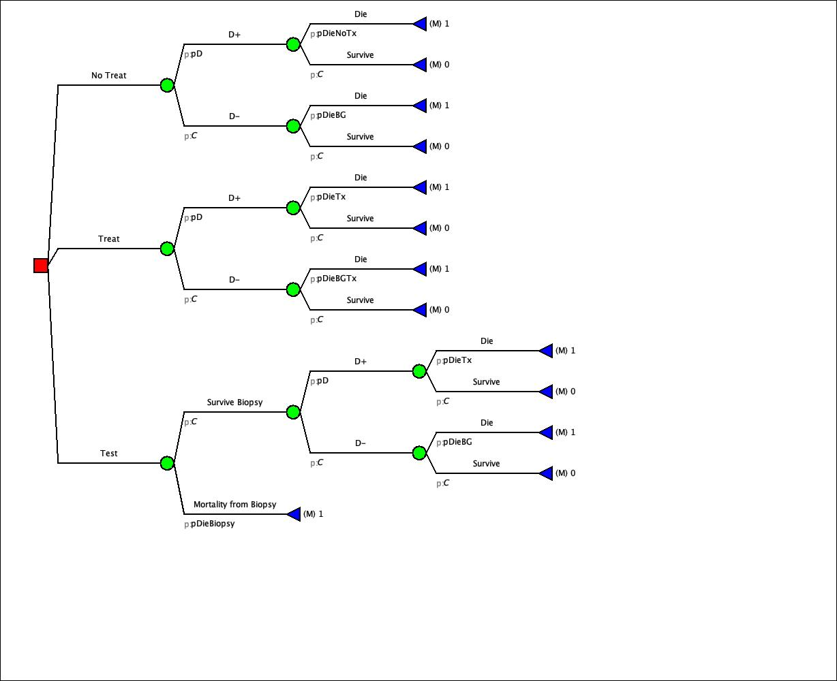

(b) Calculate the following from the decision tree you constructed in part (a). Note that the first three will be in algebraic form since we do not know the pr(D+)

1. Expected mortality, no treat;

2. Expected mortality, treat;

3. Expected mortality, test;

4. Treatment threshold (interpret result)

5. No treat-test threshold (interpret result)

6. Test-treat threshold (interpret result)

The thresholds can be calculated algebraically as follows (“roll-back” tree as you’ve done before):

**Expected mortality (No Treat) = 0.05pD**

**Expected mortality (Test)= 0.005+0.995*0.015pD**

**= 0.014925pD + 0.005**

**Expected mortality (Treat)= 0.015pD + 0.01*(1-pD) =0.005pD + 0.01**

**Treatment threshold:**

Expected mortality (No Treat) = Expected mortality (Treat)

0.05pD = 0.005pD + 0.01

0.045pD = 0.01

pD = 0.01 / 0.045 = **0.22**

If the risk of disease is 0.22, there is no clear preference between treat vs. not treat.

**No Treat – Test threshold:**

Expected mortality (No Treat) = Expected mortality (Test)

0.05pD = 0.014925pD + 0.005

0.035075pD = 0.005

pD = 0.005 / 0.035075= **0.143**

If the risk of disease is < 0.143, you’re not going to treat or get a test.

**Test – Treat threshold:**

Expected mortality (Test) = Expected mortality (Treat)

0.014925pD + 0.005 = 0.005pD + 0.01

0.009925pD = 0.005

pD = 0.005/ 0.009925 = **0.504**

If the risk of disease is > 0.504, it’s more preferable to treat than getting a test.